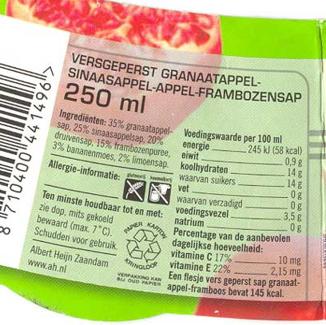

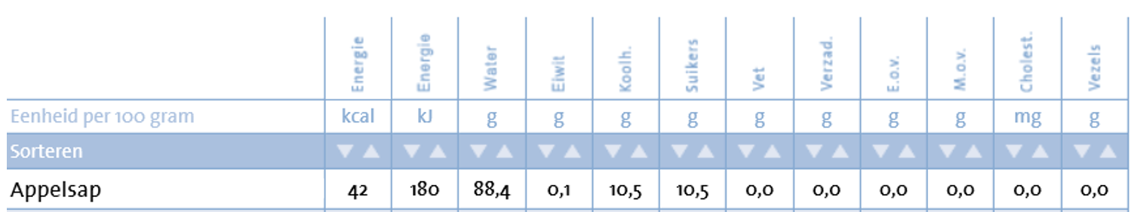

[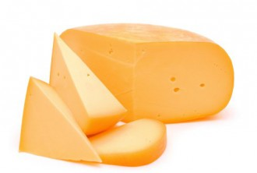](http://www.google.nl/url?sa=i&rct=j&q=&esrc=s&source=images&cd=&cad=rja&uact=8&ved=0ahUKEwjQpciM6eHQAhVFPRQKHebnCJIQjRwIBw&url=http://www.larakwant.nl/news/kaas&bvm=bv.140496471,d.ZGg&psig=AFQjCNGhilP1HtDd9V1CIMgglkp0Ybwteg&ust=1481191128185763)[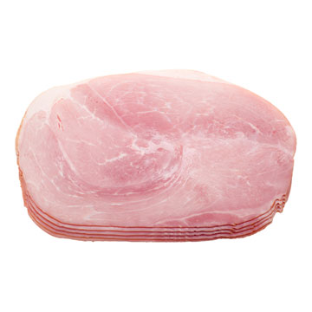](https://www.google.nl/url?sa=i&rct=j&q=&esrc=s&source=images&cd=&cad=rja&uact=8&ved=0ahUKEwiezPfyl-TQAhWFCBoKHaZ6C9QQjRwIBw&url=https%3A%2F%2Fwww.voedingswaardetabel.nl%2Fvoedingswaarde%2Fvoedingsmiddel%2F%3Fid%3D133&bvm=bv.140915558,d.ZGg&psig=AFQjCNF59nXJzEqe3b_5VtI2kDEebYn-yw&ust=1481272386488862)[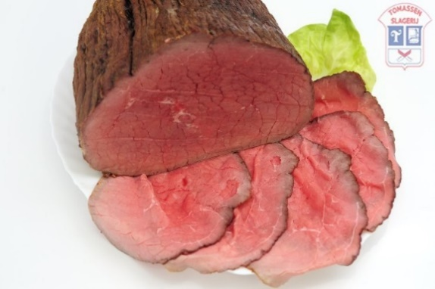](http://www.google.nl/url?sa=i&rct=j&q=&esrc=s&source=images&cd=&cad=rja&uact=8&ved=0ahUKEwj06dqq6eHQAhXIbxQKHXc5DU8QjRwIBw&url=http://www.tomassen.eu/gebraden-rosbief-1.html&bvm=bv.140496471,d.ZGg&psig=AFQjCNF4rzElAkNALqeDZH5fLy7Ai7OTpg&ust=1481191191696700)

[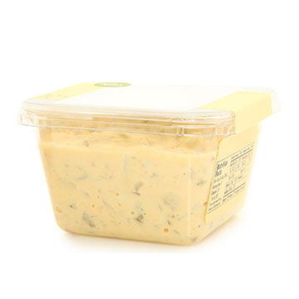](https://www.google.nl/url?sa=i&rct=j&q=&esrc=s&source=images&cd=&cad=rja&uact=8&ved=0ahUKEwjP0rWpmOTQAhUCWxoKHfbvDmkQjRwIBw&url=https%3A%2F%2Fwww.voedingswaardetabel.nl%2Fvoedingswaarde%2Fvoedingsmiddel%2F%3Fid%3D952&bvm=bv.140915558,d.ZGg&psig=AFQjCNHx4u_xUYYg_bZz_Xp_6RL_EmJSUA&ust=1481272517016132)

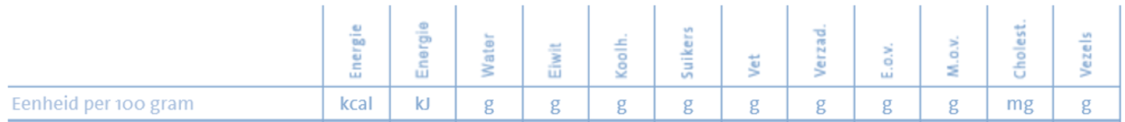









[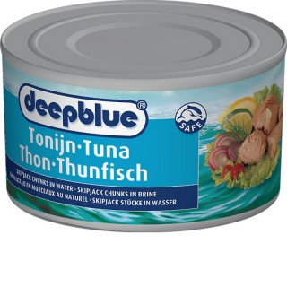](http://www.google.nl/url?sa=i&rct=j&q=&esrc=s&source=images&cd=&cad=rja&uact=8&ved=0ahUKEwjSiueS8-HQAhVLsBQKHX7yCfkQjRwIBw&url=http%3A%2F%2Fwww.dohmenconserven.nl%2Fproducten%2F%3FSkipjack-tonijn-chunks-in-brine&bvm=bv.140496471,d.ZGg&psig=AFQjCNGkuFmXG32Uk5-0YFWtpLiwlG74GQ&ust=1481193719041407) [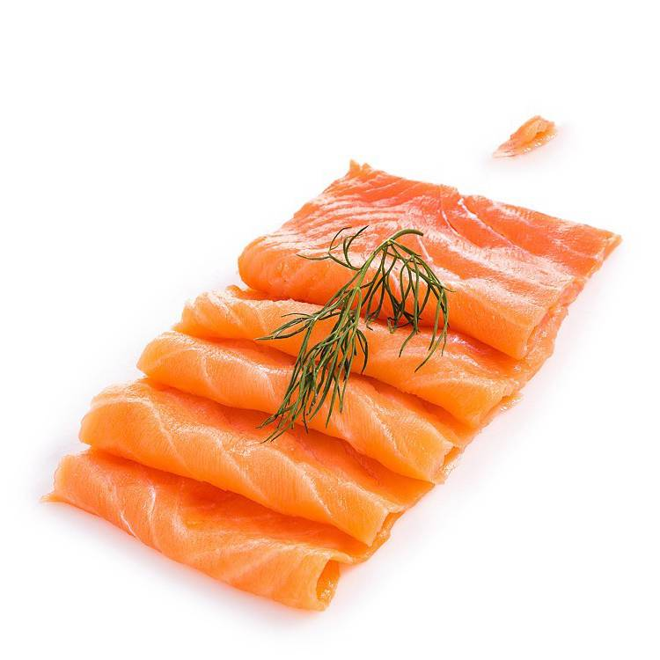](http://www.google.nl/url?sa=i&rct=j&q=&esrc=s&source=images&cd=&cad=rja&uact=8&ved=0ahUKEwjVw67B8uHQAhVBkRQKHRLcAP8QjRwIBw&url=http%3A%2F%2Fwww.devisboerthuis.nl%2Fgerookte-zalm.html&bvm=bv.140496471,d.ZGg&psig=AFQjCNHWSHI0c23dphiYwjmUpFHifjtG-g&ust=1481193655665646)

Tonijn in olie blik [ 100 gram per Stuk(s) ]

Energie 207 Kcal

Eiwit 26 g

Koolhydraten 0 g

Vet 11 g

- verzadigd 2 g

Vezels 0 g

Natrium 372 mg

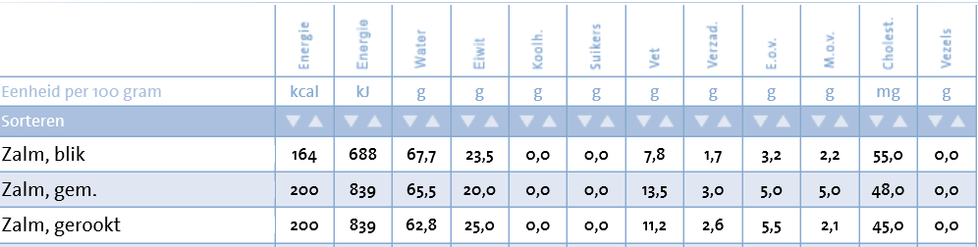

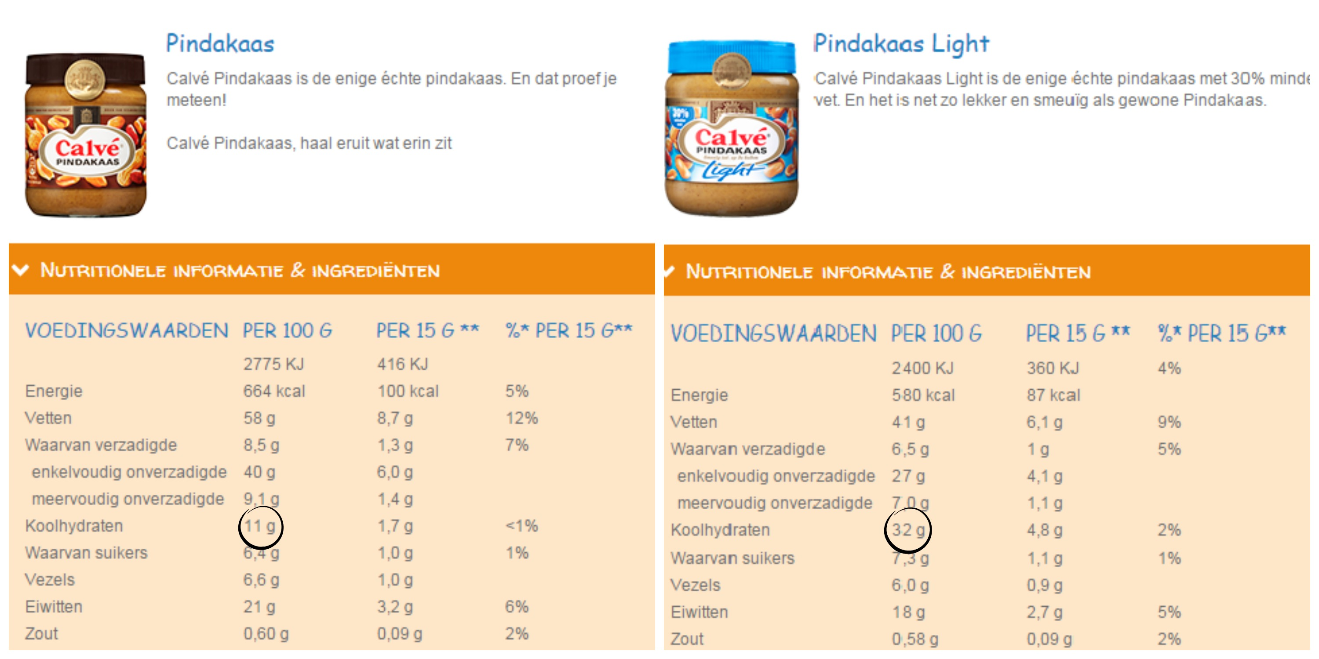

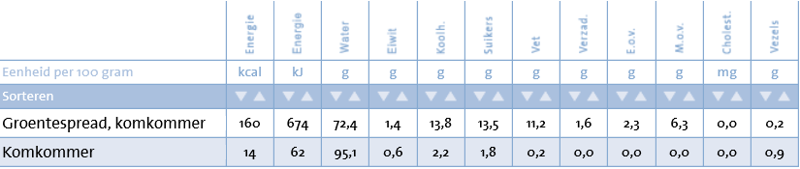 

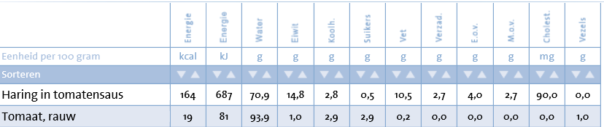 

[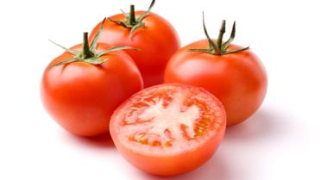](http://www.google.nl/url?sa=i&rct=j&q=&esrc=s&source=images&cd=&cad=rja&uact=8&ved=0ahUKEwi2zJr1leTQAhWD2BoKHSW-DP0QjRwIBw&url=http%3A%2F%2Fkoken.vtm.be%2Fingredienten%2Ftomaat&psig=AFQjCNE3bt2XTcO-JqRzaFlBcVtucZ7rxg&ust=1481271878112639) [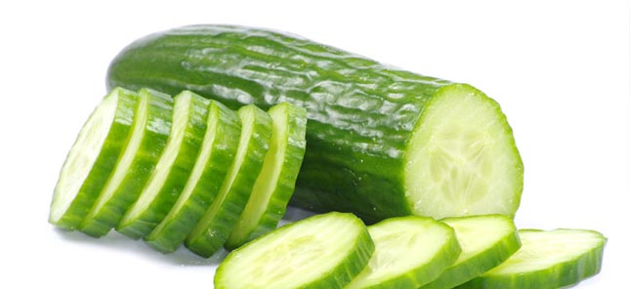](http://www.google.nl/url?sa=i&rct=j&q=&esrc=s&source=images&cd=&cad=rja&uact=8&ved=0ahUKEwjwgbKEluTQAhUEXRoKHQjjAtIQjRwIBw&url=http%3A%2F%2Fwww.ttmcommunicatie.nl%2Fnieuws%2Fkomkommertijd-6-weetjes-over-komkommers%2F&bvm=bv.140915558,d.ZGg&psig=AFQjCNGLypGaqvGGbT3YiV20esbd1SBEmw&ust=1481271912728902)